

**MODEL INSTITUTE OF ENGINEERING & TECHNOLOGY, JAMMU PROJECT REPORT TO MAKE ATM IN C**

**SUBMITTED TO: Ms. Sheetal Mahajan GROUP: 4TH**

**Gokul Kangotra (2022a1r007)**

**ABSTRACT**

Automated Teller Machine (ATM) is an electronic telecommunications device, which enables customers to perform banking without the need for direct interaction with bank staff. For this, every account holder must have a unique id card for the individual account having a unique pin. On the absence of this card, whatever be the adverse situation the use of this ATM service is not permitted. So, an Internet Of Things and Computer Vision based Smart ATM service is being proposed here, using Raspberrypi microcontroller based embedded system, where each person will be their own identity, where Fingerprint, Face, OTP verifications are key features for security, which in turn reduces the issue of fraud transactions, fraud ATM cards, hence security issue gets resolved.

**INTRODUCTION**

ATM full form is Automated Teller Machine which is a self-service banking outlet. You can withdraw money, check your balance, or even transfer funds. Different banks provide their ATM services by installing cash machines in different parts of the country. You can withdraw money from any of these machines irrespective of whether or not you are an account holder in the same bank.

Transactions are either free or bear a nominal charge depending upon the banks. Banks usually do not charge for the first 3-5 transactions in a month. Once you cross the limit of free transactions, you may have to pay a nominal charge. Also, some banks levy charges if you withdraw money from another bank’s ATM of which you are not an account holder.

**DESIGN**

The system consists of two main components

> The user interface

> The transaction processor

The user interface is designed using the basic input and output function with the help of the C language, which provides a simple menu-driven interface for the user to interact with the user The transaction processor handles deposits, withdrawal and balance inquiry transaction

**Problem Description**

This C Program performs ATM transaction. The types of ATM transaction are  
1) Balance checking  
2) Cash withdrawal  
3) Cash deposition.

**Problem Solution**

1. Firstly initialize the ATM pin and amount with some random number.  
2. Take the ATM pin as input.  
3. If the input pin is equal to the initialized pin, then do the further operations.  
4. Use switch statement to do the operations like Balance checking, Cash withdrawal, Cash deposition etc.  
5. Use while loop to terminate or restart the process.

**IMPLEMENTATION**

The implementation of the system was done in the C programing language. The user interface was designed using the basic input and output function.

And the transaction processer was implemented using conditional statements to perform deposit, withdrawal, and balance inquiry transaction based on user input.

**Flowchart**

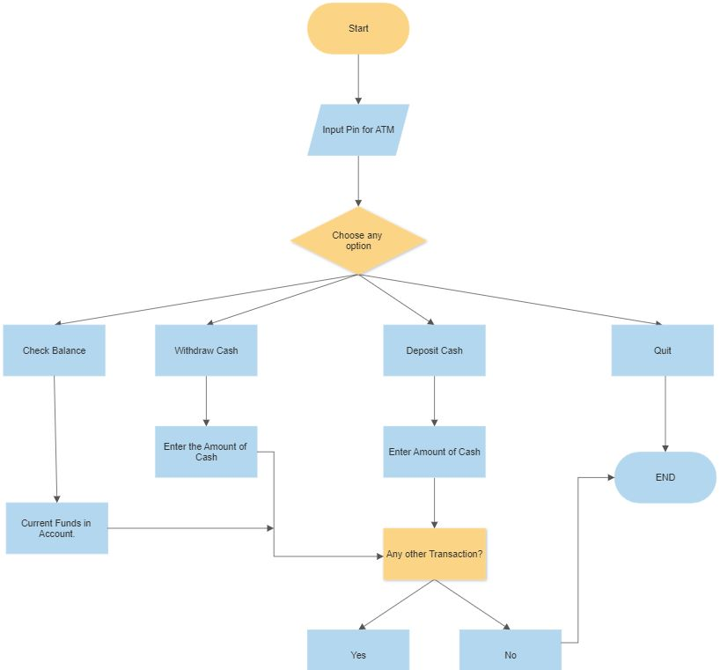

**Program**

// Header Files

#include<stdio.h>

unsigned long amount =1000,deposit,withdraw;

int choice,pin,k;

char transaction='y';

// Main Function

void main()

{

// While Loop

while(pin !=1496)

{

// Output Statement(prompt)

printf("Enter the pin number:");

// Input statement

scanf("%d",&pin);

// If statement

if (pin !=1496)

// Outputstatement(prompt)

printf("please enter valid pin\n");

}

do

{

// Output statement(prompt)

printf("********WELCOME TO ATM SERVICE********\n");

// output statement(prompt)

printf("Choose any option:\n");

// Output statement(prompt)

printf("1. check balance\n");

// Output statement(prompt)

printf("2. withdraw cash\n");

// Output statement(prompt)

printf("3. deposit cash\n");

// Output statement(prompt)

printf("4. quit\n");

// Output statement(prompt)

printf("**************?**************?*\n\n");

// Output statement(prompt)

printf("Enter your choice: ");

// Input statement

scanf("%d",&choice);

// Switch Statement

switch (choice)

{

case 1:

// Outputstatement(prompt)

printf("\n YOUR BALENCE IN Rs ; %lu", amount);

break;

case 2:

// Outputstatement(prompt)

printf("\n ENTER THE AMOUNT TO WITHDRAW: ");

// Input Statement

scanf ("%lu", &withdraw);

// If Else

if (withdraw % 100 !=0)

{

// Outputstatement(prompt)

printf("\n PLEASE ENTER THE AMOUNT IN MULTIPLES OF 100");

}

else if (withdraw >(amount - 500))

{

// Outputstatement(prompt)

printf("\n INSUFFICENT BALANCE");

}

else

{

amount=amount-withdraw;

// Outputstatement(prompt)

printf("\n\nPLEASE CORRECT CASH");

// Outputstatement(prompt)

printf("\n YOUR CURRENT BALANCE IS %lu",amount);

}

break;

case 3:

// Outputstatement(prompt)

printf("\n ENTER THE AMOUNT TO DEPOSIT");

// Input Statement

scanf("%lu",&deposit);

amount = amount + deposit;

// Outputstatement(prompt)

printf("YOUR BALANCE IS %lu",amount);

break;

case 4:

// Outputstatement(prompt)

printf("\n THANK YOU FOR USING ATM");

break;

default:

// Outputstatement(prompt)

printf("\n INVALID CHOICE");

}

// Outputstatement(prompt)

printf("\n\n\n DO YOU WISH TO HAVE ANOTHER TRANSACTION?(y/n):\n");

fflush(stdin);

// Input Statement

scanf("%c",&transaction);

if (transaction=='n'||transaction=='N')

k=1;

}

// While Loop

while(!k);

// Output Statement (prompt)

printf("\n\n THANKS FOR USING OUR ATM SERVICE\n");

}

**Program Explanation**

1. Initialize the variables pin, amount and transaction with 1520, 1000 and ‘y’ respectively.  
2. Ask for the pin from user. If the input pin is equal to 1520, then allow for the further operations.  
3. Use switch statement to do the operations like Check Balance, Withdraw Cash, Deposit Cash and Quit.  
4. For Check Balance simply print the variable amount as output and exit.  
5. For Withdraw Cash, first ask the amount to withdraw and store it in the variable withdraw. 6. If withdraw % 100 != 0, then ask user to enter the amount in multiplies of 100.  
7. If withdraw amount is greater than (amount-500), then print the output as “INSUFFICENT BALANCE”.  
8. Otherwise subtract the variable withdraw from variable amount, print the amount and exit.  
9. For deposit operation, ask the user for amount and store it in the variable deposit.  
10. Add the variable deposit to variable amount, print the amount and exit.  
11. If quit, then finally ask the user if they wish to continue or not. Ask them to type y/n and store it in the variable transaction.  
12. If variable transaction is y/Y, then continue the operation. Otherwise terminate the while loop by assigning 1 to variable k.

**ScreenShots of Program**

**Home Page of ATM :-**

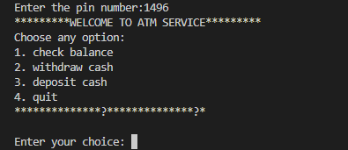

**Choice 1. Checking Balance** : -

**Asking if User have another Transaction:**

**Case 1: Yes**

**Choice 3. Deposit Cash:**

**Choice 4. Quit:**

**Asking if User have another Transaction:**

**Case 2: No**

**CONCLUSION**

After testing our program we can conclude that our ATM program can do the basic function transaction functions like withdrawal, deposit and check balance.